Manual Book of
SUPPLIER WEB

供應商使用手冊

Default Homepage – 首頁
- User dapatmenggunakan browser internet untukmenuju situs web. Alamat situs Supplier Web adalah http://supplier.panbrothers.co.id
使用者請依照以下網址進入供應商系統: http://supplier.panbrothers.co.id
Please enter the following internet address to enter the supplier website
- Pada tampilan awal Supplier Web, user di haruskan login menggunakan username dan password yang sudah di buatkan.
進入網頁後,請依照先前提供的密碼以及使用者身分輸入網頁
After enter the website, please enter the pre-designated user ID and password.
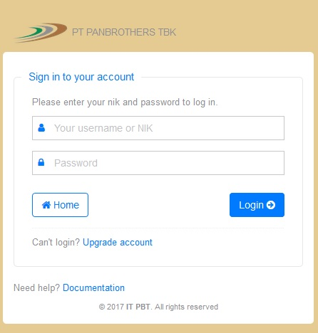
Gambar : Web Login (輸入網頁)

- Setelahberhasil login, akanmuncul default homepage Supplier Web.Padatampilanawal di default homepage, hanyaakanmuncul menu Dashboard, Profile Company dan Terms And Conditions.
輸入使用者以及密碼後, 在介面上(Dashboard)將會出現公司資料(company profile)以及交易條件(terms and conditions).
After enter the USERNAME and PASSWORD correctly, on the screen click into DASHBOARD, the screen should appear both COMPANY PROFILE and TERMS AND CONDITIONS.
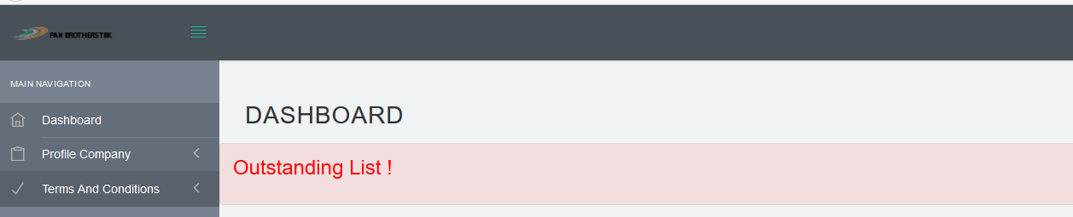
Gambar : Dashboard (介面畫面)

- Di Sub Menu dari Terms And Conditions akanmuncul menu Code of Conduct (COC) dan Know Your Customer (KYC).
進去交易條件內(terms and conditions)將會有企業行為守則(Code of Conduct – COC)以及供應商細節(know your customer –KYC)
Click in the Sub Menu from TERMS AND CONDITIONS, there should be both CODE OF CONDUCT(COC) and KNOW YOUR CUSTOMER (KYC)
- Silahkanisifield Name dan Position di Menu Code of Conduct (COC), danklikkotakkecil di sisikiripernyataan “I have read and agree/accept to the Terms and Conditions of the COMMITMENT Code of Conduct (CoC)”
煩請在企業行為守則(code of conduct-COC)填入相關細節,並選擇我已經詳讀並同意遵守企業行為守則(“I have read and agree/accept to the Terms and Conditions of the COMMITMENT Code of Conduct (CoC)”
)
Please fill-in the Names and Positions in the CODE OF CONDUCT (COC) and please click the option “(“I have read and agree/accept to the Terms and Conditions of the COC”.

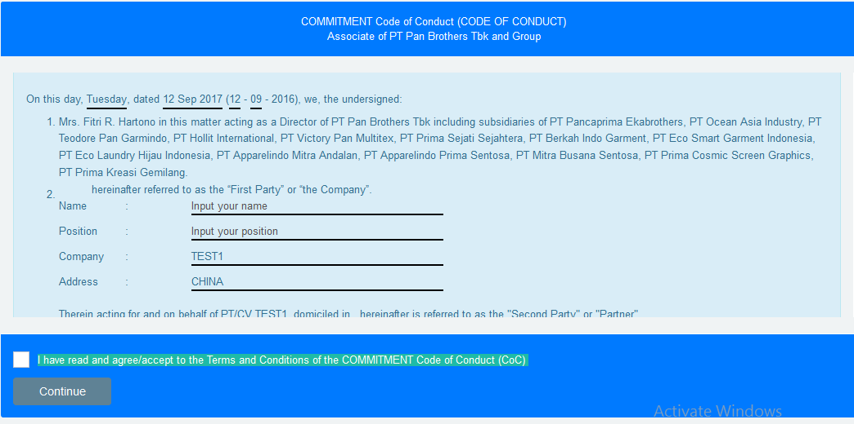
Gambar : Code Of Conduct(介面-企業行為守則)

- Klik Continue untukmelanjutkan.
之後煩請按(continue)進入下一個介面.
Click CONTINUE button and enter the next menu.
PO Info -> List PO :Berisikan informasi mengenai PO.
訂單資訊(PO info) ->所有貴司訂單相關資訊
PO INFO- All the available Purchase Information for your company
- Pada Menu PO Info, pilih List PO.
在訂單介面選項(PO INFO),選擇訂單清單(LIST PO)
In the PO menu, click List PO.
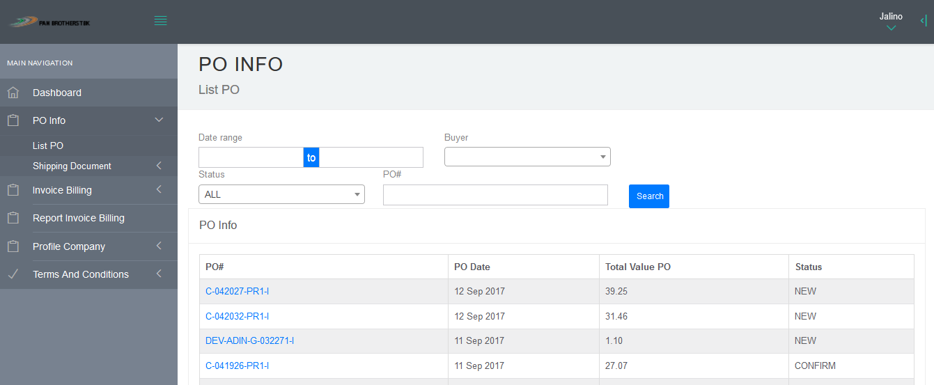
Gambar: List PO (介面 – 訂單清單)

- Ketikkan No PO di kolom PO#, kemudian klik Search, makaakan muncul No.PO dantanggal pembuatan PO di kolom PO Info. Pada PO Info terdapat kolom status yang berisikan New, Notes dan Confirm. PO bias di proses
jika statusnya adalah confirm.
在訂單號碼欄位內(PO#)輸入訂單號碼,並按進搜尋(search),將會顯示該訂單相關資訊.新輸入訂單(NEW),審核中(NOTES)以及訂單確認(CONFIRM)將會顯示在相關資訊上.該訂單在訂單確認(CONFIRM)代表已經確認審核並處理訂單中.
In the PO# column please enter the PO number and then click SEARCH, the system should display all relevant information regarding the PO. If the status is NEW it means its not yet been approved. If the status is NOTES it means it is under process, and if the status is CONFIRM it means the PO is approved.
- Klik No Po, makaakanmuncul details informasimengenai PO tersebut.
按進去訂單號碼(PO NUMBER),相關細節將會顯示在介面上.
Click In the PO#, and all the relevant information regarding this particular purchase order will be displayed.
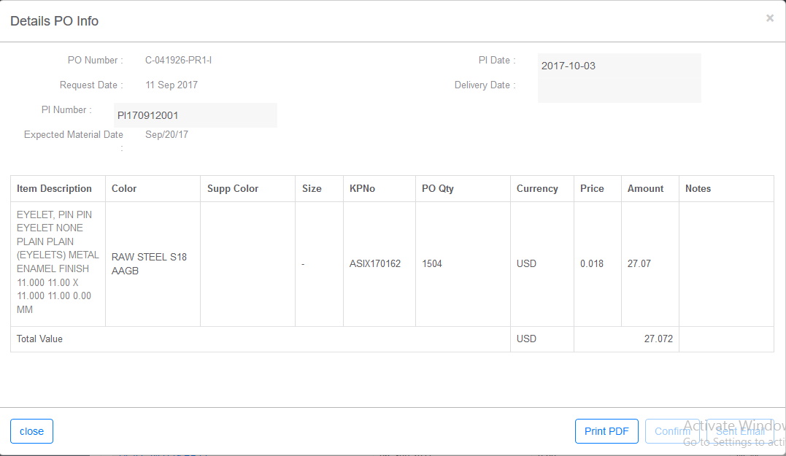
Gambar: Details PO Info (介面-訂單細節)
- Masukkan PI Number, PI Date dan Delivery Date.
輸入預開發票號碼(PI NUMBER),日期(PI DATE)以及交期(DELIVERY DATE)
Enter PI NUMBER, PI DATE and DELIVERY DATE.
- User dapat menambahkan Notes pada PO, jika ingin ada catatan terhadap PO tersebut. Untuk menambahkan Notes pada PO, silahkan KlikNo.PO pada PO Info, kemu dianklik icon .
使用者若需要更改該訂單細節,在備忘錄上(NOTES)輸入相關資訊,並按圖標.
You can change the particular PO details by editing on the NOTES and enter relevant changes. To make changes on the PO please click on the icon.
- User dapat di menambahkan catatan mengenai PO tersebut di kolom Notes, kemudianklik Save Notes.
使用者在備忘錄(NOTES)欄位內輸入該訂單變更相關資訊,輸入完畢後按進儲存(SAVE NOTES)
You may enter all the relevant changes in the NOTES column for the PO, and click SAVE NOTES after finished the necessary amendments.
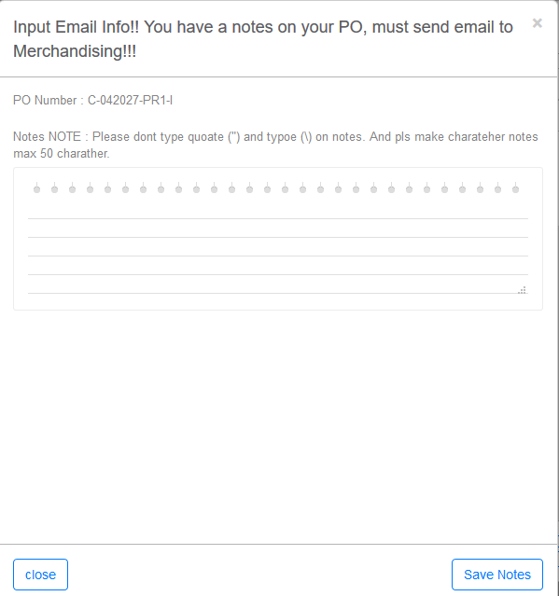
Gambar: Input Notes (介面 – 備忘錄)

- Jika PO tersebut sudah sesuai, user dapat confirm PO tersebut dengan menekantombol confirm.
當該訂單(PO)相關細節已經確無誤,使用者可以按確認鍵(CONFIRM)來確認該訂單.
If the particular is already in accordance with the changes, the user can click CONFIRM button to complete the update.

PO Info -> Shipping Document -> Attach Document :Melampirkandokumen shipping (Full Shipment)
訂單資訊(PO INFO)->出貨文件(SHIPPING DOCUMENT)->上傳文件(ATTACH DOCUMENT)上傳所有出貨文件
PO INFO – SHIPPING DOCUMENT – ATTACH DOCUMEN – upload all the shipping documents.
- Pada Menu PO Info, pilih Shipping Document, kemudianpilih Attach Document.
在訂單資訊(PO INFO)介面上,選擇出貨文件(SHIPPING DOCUMENT)選項並選擇上傳文件(ATTACH DOCUMENT)
In the PO menu, click SHIPPING DOCUMENTS, and then click ATTACH DOCUMENT.

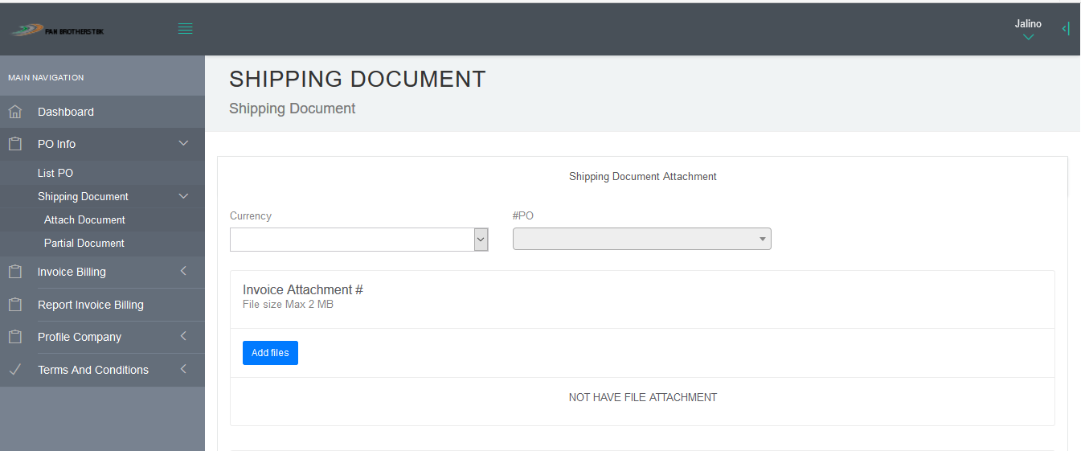
Gambar: Full Shipping Document (介面-所有出貨文件)

- Pilih Currency, kemudian ketikkan No PO yang ingin di dokumennya di attach. Klik Add Files pada masing-masing attachment
選擇幣別(CURRENCY),之後選擇想上傳文件的訂單號碼(#PO),按進新增檔案(ADD FILES)鍵並加入您所想要上傳文件.
Choose the CURRENCY and then choose the Purchase Order number (PO#) that you wish to upload the shipping documents. Click Add FILES and upload the shipping documents.
- Pilih Files yang ingin di attach, klik Open.Ukuran maksimal files yang bisa di attach adalah2 Mb.
選好您要上船的文件後,按開啟(OPEN),最大文件上傳大小為2MB.
After you have finished choosing the files you wish to attach, click OPEN, and the maximum size per file is 2MB

PO Info -> Shipping Document -> Attach Document :Melampirkan dokumen shipping (Full Shipment)
- 訂單資訊(PO INFO)->出貨文件(SHIPPING DOCUMENT)->上傳文件(ATTACH DOCUMENT)上傳所有出貨文件
PO INFO – SHIPPING DOCUMENT – ATTACH DOCUMENT – upload your shipping documents
- Pada Menu PO Info, pilih Shipping Document, kemudian pilih Partial Document.
在訂單資訊(PO INFO)介面上,選擇出貨文件(SHIPPING DOCUMENT)選項並選擇部分出貨文件(PARTIAL DOCUMENT)
In the PO INFO display, click SHIPPING DOCUMENT and choose PARTIAL DOCUMENT
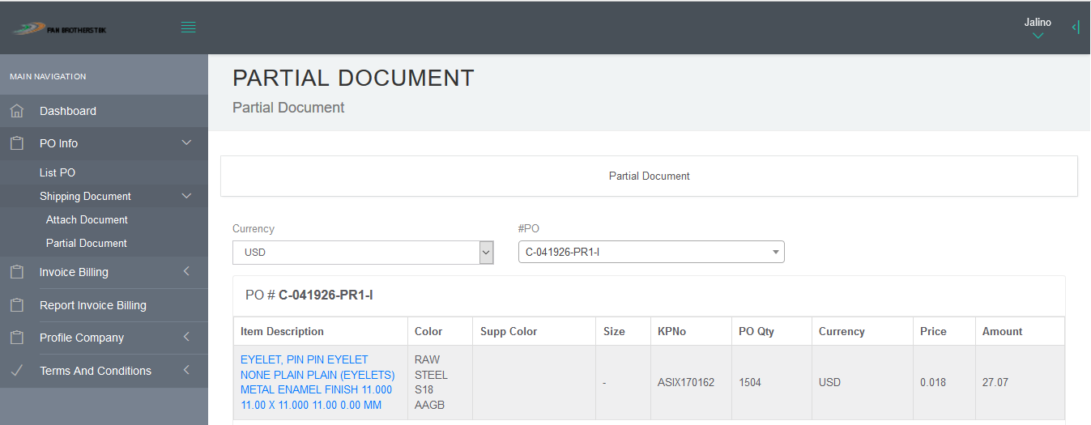
Gambar: Partial Document (介面-部分文件)

- Pilih Currency, kemudianpilih No PO yang ingin di dokumennya di attach. Klik Item Description yang di pilih.
選擇幣別(CURRENCY),之後選擇想上傳文件的訂單號碼(#PO),按進訂單說明(ITEM DESCRIPTION).
Choose the CURRENCY, and the Purchase Order Number (PO#) of the particular PO you wish to upload the documents, and then click ITEM DESCRIPTIOIN

- Terdapat3 partial shipment yang bisa di input.
接著可以輸入部分出貨文件選項
Then following please enter PARTIAL SHIPMENT info.

- MasukkanTanggal actual pengiriman di kolom Act Time Delivery.
在實際出貨日欄位中(ACT TIME DELIVERY)輸入實際出貨日
Please enter the actual date of delivery in ACT TIME DELIVERY Column.
- Masukkan jumlah yang ingin di kirim di kolom Qty Act Delivery.
在實際出貨量欄位中(QTY ACT DELIVERY)輸入實際出貨量
Please enter the actual Quantity delivered in QTY ACT DELIVERY Column
- Masukkan Ship Mode.
輸入出貨形式(SHIP MODE)
Please enter the Shipment mode in SHIP MODE Column.
- Masukkan No Invoice di kolom INV#.
在訂單號碼欄位中(INV#)輸入訂單號碼
Please enter Invoice Number in (INV#)
- Pilih Files yang ingin di attach, dengan menekantombol Add File di kolom Invoice File.
選擇想要上傳的文件,並按新增檔案鍵(ADD FILE)來上傳文件.
Choose the files that you wish to upload and click ADD FILES to upload the documents.
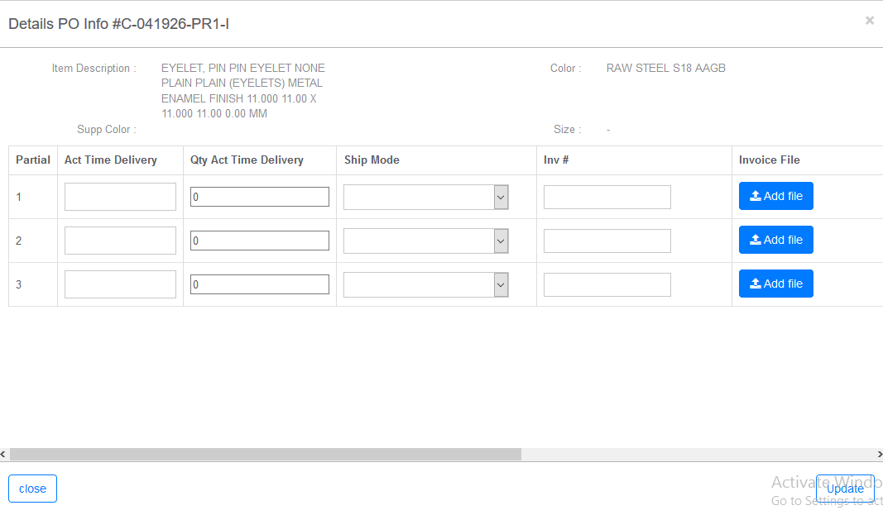
Gambar: Detail Partial Document(介面-部分出貨文件)
Invoice Billing -> Add New : Input PO yang ingin ditagihkan pembayarannya.
發票結算(INVOICE BILLING)->新增(ADD NEW):新增需要請款的訂單號碼
Invoice Billing – Click ADD NEW to input the Invoice Number for billing
- Pada Menu Invoice Billing, pilih Add New.
在發票結算(INVOICE BILLING)介面上,選擇新增(ADD NEW)
In the Invoice Billing Menu, click ADD NEW
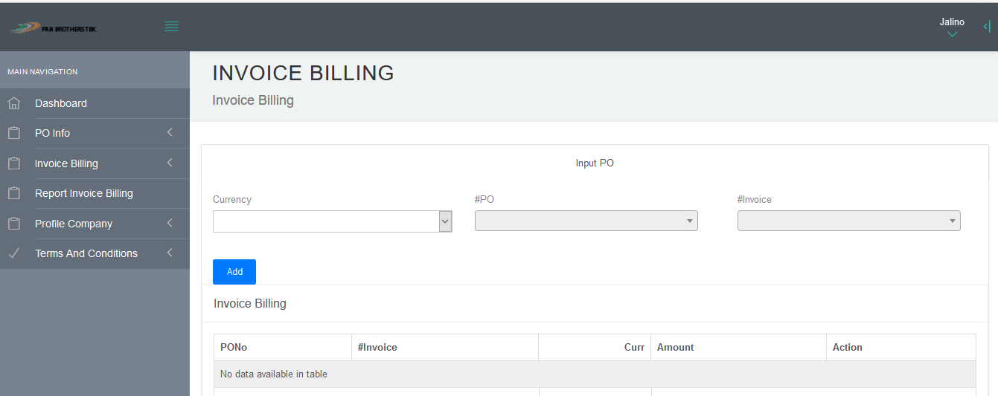
Gambar: Invoice Billing(介面-發票結算)

- Padahalaman Invoice Billing,pilih Currency, kemudianketikkan No PO yang ingin di tagihkanpembayarannnya. Klik Add.
在發票結算(INVOICE BILLING)介面上,選擇幣別(CURRENCY),然後選擇想要請款的訂單號碼(#PO)後,按新增(ADD)
In the INVOICE BILLING display, choose CURRENCY and then choose the Purchase order number (PO#) that you wishes to create invoice billing, and then click ADD.
- Jika yang ingin di tagihkan pembayarannya lebih dari satu PO, makaketikkan No PO kedua dan klik add untuk setiap penambahannya.
若要申請多張訂單請款,按新增鍵(ADD)然後選擇需要請款的訂單號碼.
If you would like to bill multiple invoices, enter the desired PO# and then click ADD.
- Akan munculnilai amount dan total dari PO tersebut.
之後確認所有訂單加起來的金額.
Please confirm the total amount of the PO.
- Klik Save jika memang sudah benar.
若確認無誤後按儲存鍵(SAVE)
Once confirmed click SAVE button.
- Setelah Klik Save,user akan mendapatkan No Invoice Billing.
按完儲存鍵(SAVE)後,使用者將會收到發票結算號碼.
After clicking on SAVE button, you should receive the number of Invoice billing from the system.

Invoice Billing ->All :digunakan jikaingin preview/edit/delete Invoice Billing.
發票結算(INVOICE BILLING)->所有選項(ALL):若使用者需要預查/修改/刪除發票結算
Invoice Billing – Click All if you need to preview/edit/delete the invoice billing
- Pada Menu Invoice Billing, Pilih All.
在發票結算(INVOICE BILLING)介面上,選擇全部(ALL)
In the Invoice Billing display, click ALL.
- Padahalaman List Invoice Billing, ketikkan No Invoice Billing yang ingin di edit/delete,kemudianKlik Search.
在發票結算清單上,輸入想要修改/刪除的訂單號碼,並按搜尋(SEARCH)
In the List Inovice Billing display, click Invoice Billing Number that you wish to edit/delete, and then click Search.
- Akan Muncul No Invoice Billing yang di cari.
介面上會出現使用者搜尋的發票號碼.
The system will show the searched results on the Invoice Billing Number.
- Klik Delete jika inginmenghapus No PO, kemudian klik Update untuk menyimpan perubahannya.
若要刪除該訂單,按刪除鍵(DELETE),然後按更新鍵(UPDATE),介面上就會顯示更新後內容.
To delete this particular Invoice Billing, click DELETE button, and then click UPDATE, the system should display updated info.

Report Invoice Billing : Berisikan Seluruh Invoice Billing dalam range waktu
tertentu
發票結算報告(REPORT INVOICE BILLING):在選擇時間範圍內搜尋所有發票資料
Report Invoice Billing – Search all the invoice billing within time frame.
- Pilih Report Invoice Billing.
在介面上選擇發票結算報告(REPORT INOVICE BILLING)
In the display click Report Invoice Billing
- Padahalaman Report invoice Billing, pilih periode waktu tertentu di kolom Date Range,kemudiankliktombol Search.
在發票結算報告介面上,按日期範圍(DATE RANGE)輸入要搜尋日期範圍後,按搜尋鍵(SEARCH)
In the Report Invoice Billing display, click DATE RANGE, enter the time frame that you wishes to enquire, and then click SEARCH.
- Makaakan di tampilkanseluruh Invoice Billing di tangaltersebut.
之後系統將會依照使用者所輸入的日期範圍內搜尋所有發票資訊,
The System will search all the billing invoices within the time frame that you have entered.

Profile Company -> Company Information : Berisikan Informasi mengenai
Supplier
公司簡介(COMPANY PROFILE) -> 公司資訊 : 輸入供應商相關資料
Company Profile – Enter supplier information.
Pada Menu Profile Company, pilih Company Information.
在公司簡介(COMPANY PROFILE)介面上,選擇公司資料(COMPANY INFOMRATION)
In the Company Profile display, click COMPANY INFORMATION
Di halaman Your Company Profile Information, akan berisi detail informasi mengenai supplier.
在使用者公司簡介資料介面上,輸入供應商公司相關資料
In the Your Company Profile Information display, enter all the relevant information required.
User dapat mengedit profile information (kecuali NPWP) dengan kliktombol Edit
Profile. Makaakan munculhalaman Edit Supplier.
若使用者需要修改公司簡介資料(除了稅務編號以外),按修改鍵(EDIT PROFILE),並更新相關資料.
If you need to update your company profile (except for Tax Registration Number NPWP), click EDIT PROFILE and update changes that is needed.
Kliktombol Update untukmenyimpanperubahan
修改後按更新鍵(UPDATE)來完成修改作業.
Click the UPDATE button after you have finished all the changes.

